**Narendra Modi Biography**

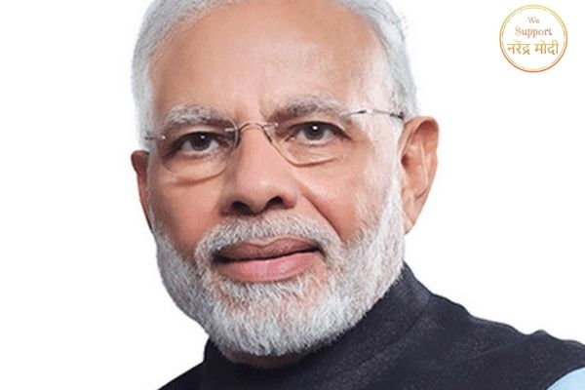

Narendra Modi, in whole Narendra Damodardas Modi, (born September 17, 1950, Vadnagar, India), is an Indian politician and government official who ascended to fit as a senior leader of the Bharatiya Janata Party (BJP). In 2014 he started his party to victory in elections to the Lok Sabha (lower chamber of the Indian parliament), after which he was declared as prime minister of India. Before that, he had worked (2001–14) as chief minister (head of government) of Gujarat state in western India.

**Modi's Early Life And Political Career**

Modi was born in a small town in northern Gujarat, and he completed an M.A. degree in political science from Gujarat University in Ahmedabad. He entered the pro-Hindu Rashtriya Swayamsevak Sangh (RSS) organization in the early 1970s and set up a unit of the RSS’s students’ wing, the Akhil Bharatiya Vidyarthi Parishad, in his field. Modi grew steadily in the RSS ministry, and his connection with the RSS organization significantly assisted his following political occupation.

**For More Details Follow-** <https://www.wesupportnarendramodi.com/narendra-modi-biograbhy/>